INTERFACE IN JAVA
An interface in java is a blueprint of a class. It has static constants and abstract methods.The interface in java is a mechanism to achieve abstraction and multiple inheritance.

Interface is declared by using interface keyword. It provides total abstraction; means all the methods in interface are declared with empty body and are public and all fields are public, static and final by default. A class that implement interface must implement all the methods declared in the interface.

Syntax:
interface <interface_name>
{
// declare constant fields
// declare methods that abstract
// by default.
}
Relationship between classes and interfaces
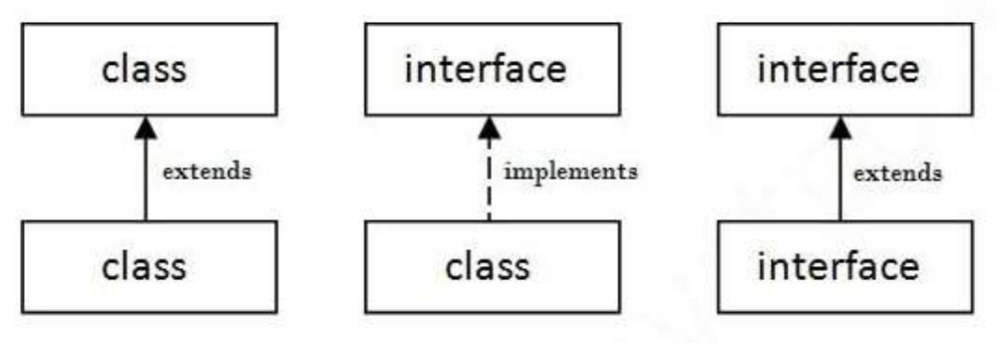

Key points to remember about interfaces:
1) We can’t instantiate an interface in java. That means we cannot create the object of an interface
2) Interface provides full abstraction as none of its methods have body. On the other hand
abstract class provides partial abstraction as it can have abstract and concrete(methods with
body) methods both.
3) “implements” keyword is used by classes to implement an interface.
4) While providing implementation in class of any method of an interface, it needs to be
mentioned as public.
5) Class that implements any interface must implement all the methods of that interface, else the
class should be declared abstract.
6) Interface cannot be declared as private, protected or transient.
7) All the interface methods are by default abstract and public.
8) Variables declared in interface are public, static and final by default.
interface Try
{
int a=10;
public int a=10;
public static final int a=10;
final int a=10;
static int a=0;
}
All of the above statements are identical.
9) Interface variables must be initialized at the time of declaration otherwise compiler will throw
an error.
interface Try
{
int x;//Compile-time error
}
Above code will throw a compile time error as the value of the variable x is not initialized at the
time of declaration.
10) Inside any implementation class, you cannot change the variables declared in interface
because by default, they are public, static and final. Here we are implementing the interface
“Try” which has a variable x. When we tried to set the value for variable x we got compilation
error as the variable x is public static final by default and final variables can not be re-initialized.
class Sample implements Try
{
public static void main(String args[])
{
x=20; //compile time error
}
}
11) An interface can extend any interface but cannot implement it. Class implements interface
and interface extends interface.
12) A class can implement any number of interfaces.
13) If there are two or more same methods in two interfaces and a class implements both
interfaces, implementation of the method once is enough.
interface A
{
public void aaa();
}
interface B
{
public void aaa();
}
class Central implements A,B
{
public void aaa()
{
//Any Code here
}
public static void main(String args[])
{
//Statements
}
}
14) A class cannot implement two interfaces that have methods with same name but different
return type.
interface A
{
public void aaa();
}
interface B
{
public int aaa();
}
class Central implements A,B
{
public void aaa() // error
{
}
public int aaa() // error
{
}
public static void main(String args[])
{
}
}
15) Variable names conflicts can be resolved by interface name.
interface A
{
int x=10;
}
interface B
{
int x=100;
}
class Hello implements A,B
{
public static void Main(String args[])
{
System.out.println(x);
System.out.println(A.x);
System.out.println(B.x);
}
}
Advantages of interface in java:
• Without bothering about the implementation part, we can achieve the security of
implementation
• In java, multiple inheritance is not allowed, however you can use interface to make use of
it as you can implement more than one interface.
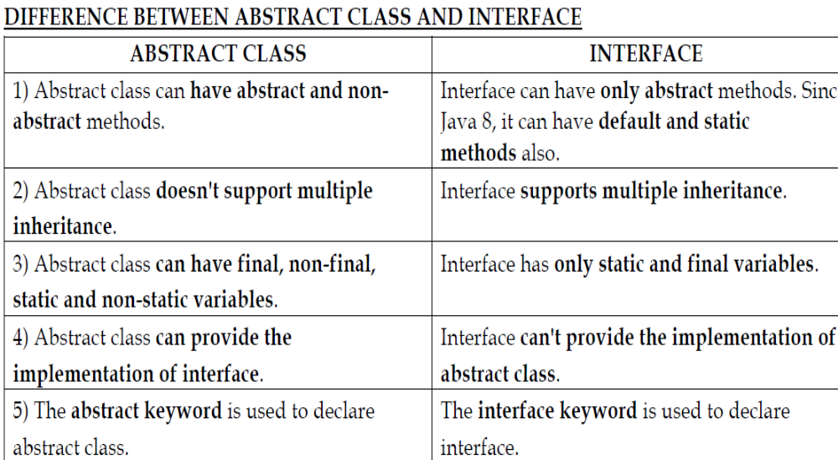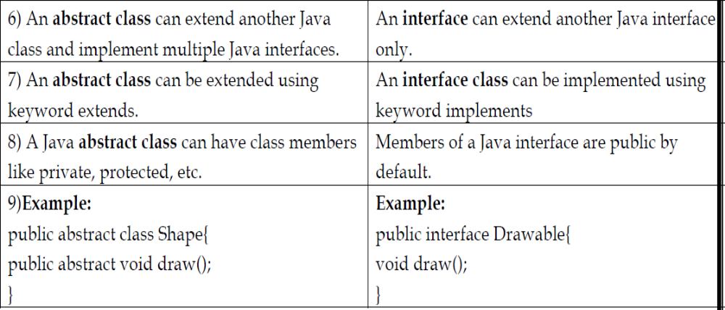

Example:1

package p1;
interface A
{
int a=5;
int b=6;
public void fun1();
public void fun2();
}
class B implements A
{
public void fun1()
{
System.out.println("a :"+a);

}
public void fun2()
{
System.out.println("b :"+b);
}
}
public class InterfaceExample
{
public static void main(String[] args)
{
A a1;
B obj=new B();
a1=obj;
a1.fun1();
a1.fun2();
}
}

Example 2:
package p2;
interface A
{
int a=10;//default is public static final
int b=20;
public void fun1(); // by default public abstract
public void fun2();

}
interface B
{
int c=30;
public void fun3();
}
public class Test2 implements A,B {

public void fun1()
{
a=90;
System.out.println("fun1 "+a);
}
public void fun2()
{
System.out.println("fun2 "+b);

}
public void fun3()
{
System.out.println("fun3 " +c);
}
public static void main(String[] args) {
// TODO Auto-generated method stub
/*
Test2 t2=new Test2();
t2.fun1();
t2.fun2();
t2.fun3();

*/
Test2 t1=new Test2();
A a1;
a1=t1;
a1.fun1();
a1.fun2();

Test2 t2=new Test2();
B b1;
b1=t2;
b1.fun3();

}

}

Example 3:

interface printable{
void print();
}
class A6 implements printable{
public void print(){System.out.println("Hello");}
public static void main(String args[]){
A6 obj = new A6();
obj.print();
}
}
Output:
Hello

Multiple inheritance in Java by interface
If a class implements multiple interfaces, or an interface extends multiple interfaces i.e. known as multiple inheritance.
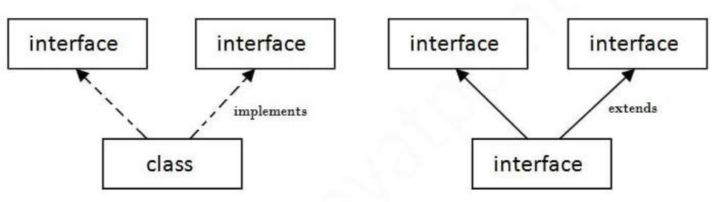
Example 4:
interface Printable
{
void print();
}
interface Showable
{
void show();
}
class A7 implements Printable,Showable
{
public void print()
{
System.out.println("Hello");
}
public void show()
{
System.out.println("Welcome");
}
public static void main(String args[])
{
A7 obj = new A7();
obj.print();
obj.show();
}
}
Output:
Hello
Welcome
Interface inheritance

Example 5:

A class implements interface but one interface extends another interface .
Example:
interface Printable
{
void print();
}
interface Showable extends Printable
{
void show();
}
class TestInterface4 implements Showable
{
public void print()
{
System.out.println("Hello");
}
public void show()
{
System.out.println("Welcome");
}
public static void main(String args[])
{
TestInterface4 obj = new TestInterface4();
obj.print();
obj.show();
}
}
Output:
Hello
Welcome
Example 6:
Develop a java program to define an interface "Vehicle" with abstract methods, changegear(gear:int) and speedup():void. the Class Car has gear and speed as attributes and must implement Vehicle. the speedup( )increments the speed. Write the VehicleDemo class with main() method to instantiate Car and invoke the abstract methods.
interface Vehicle
{
public abstract void changeGear(int gear);

public abstract void speedUp();
}
class Car implements Vehicle
{
int gear;
int speed;
Car(int gear,int speed)
{
this.gear=gear;
this.speed=speed;
}
public void changeGear(int gear)
{
this.gear=gear;
}
public void speedUp()
{
speed++;
}
public String toString()
{
String msg;
msg=String.format("Vehicle is ruuning %d gear and with speed %d" , gear,speed);
return msg;
}
}
public class VehicleDemo {
public static void main(String args[])
{

vehicle ref;
Car c =new Car(1,20);
ref=c;
ref.changeGear(3);
ref.speedUp();
System.out.println(ref);

(or)
Car c =new Car(1,20);
c.changeGear(3);
c.speedUp();
System.out.println(c);
}
}

Example 7:
Develop an interface MyCalculator with 4 methods - add(), sub(), mul() and div(). Each of the above methods return an integer value. A class IntegerCalculator implements the interface and has 2 private attributes x and y. Write the main() method in CalculatorDemo class to demonstrate the abilities of IntegerCalculator.
package question9;
import java.util.Scanner;
public interface MyCalculator
{
public abstract int add();
public abstract int sub();
public abstract int mul();
public abstract int div();
}
public class IntegerCalculator implements MyCalculator
{
private int x;
private int y;
IntegerCalculator(int x,int y)
{
this.x=x;
this.y=y;
}
public int add()
{
return x+y;
}
public int sub()
{
return x-y;
}
public int mul()
{
return x*y;

}
public int div()
{
return x/y;
}
}
public class CalculatorDemo
{
public static void main(String args[])
{
Scanner sc= new Scanner(System.in);
System.out.println("Enter x,y values");
int x=sc.nextInt();
int y=sc.nextInt();
IntegerCalculator h=new IntegerCalculator(x,y);
System.out.println("Addition :"+h.add());
System.out.println("Subtraction :"+h.sub());
System.out.println("Multiplication :"+h.mul());
System.out.println("Division :"+h.div());
sc.close();
}
}

Example 8:
Develop an interface student with 3 methods - id(), name() and create a interface marks with 2 methods marks and percentage. A class Result implements the interface and has 4 private attributes id, two subjects marks,name of the student. Write the main() method class to demonstrate display the name ,id ,marks of two subjects and calculate the percentage.
package students;
import java.util.Scanner;
public interface Student
{
public abstract void id(int id);
public abstract void name(String name);
}
interface Marks
{

public abstract void percentage();

public abstract int marks(int nextInt, int nextInt2);
}
class Result implements Student,Marks
{
private static int id;
private static String name;
private static int m1;
private static int m2;
Result(int id,String name,int m1,int m2)
{
this.m1=m1;
this.m2=m2;
this.name=name;
this.id=id;
}

public void percentage()
{
int totalperce=m1+m2;
float percentage=(float)((totalperce/200)*100);
System.out.println(percentage);
}

public void id(int id) {

System.out.println(id);
}
public void name(String name)
{
System.out.println(name);
}
public int marks(int m1, int m2)
{

int total =m1+m2;
System.out.println(total);
return total;
}
public static void main(String[] args)
{
Scanner sc=new Scanner(System.in);
Result obj=new Result(sc.nextInt(),sc.next(),sc.nextInt(),sc.nextInt());
obj.id(id);
obj.name(name);
obj.marks(m1,m2);
obj.percentage();
}
}

